TASK- 3 PLATFORMS
A.CODING PLATFORM –
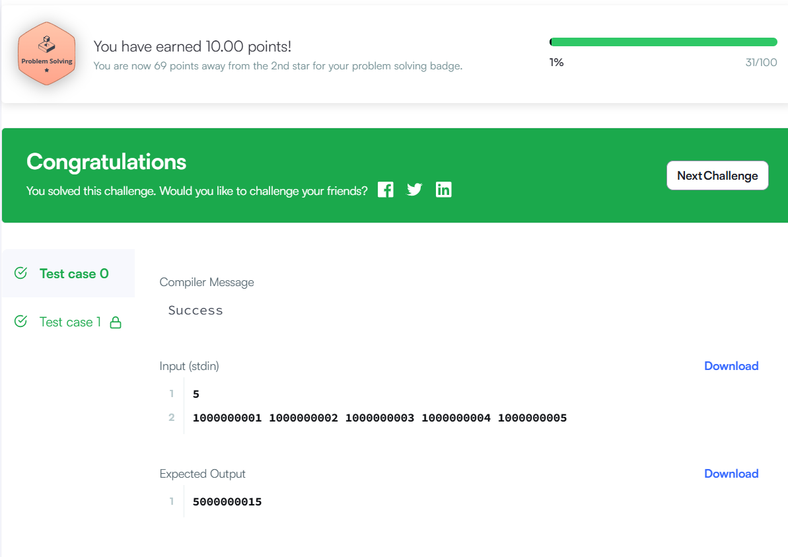

B. GOOGLE FORM –
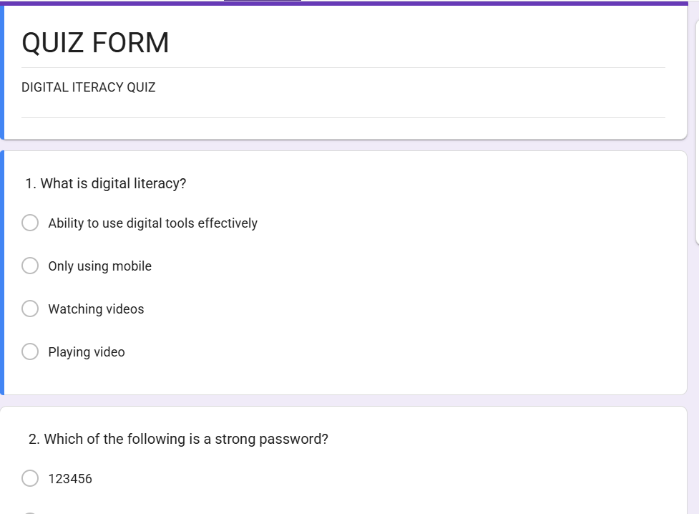
RESPONSES-
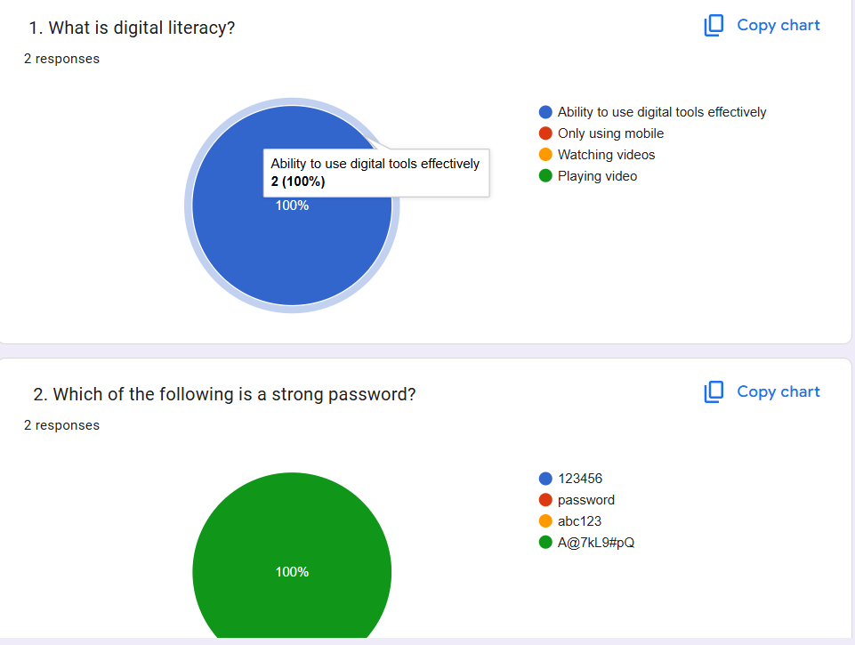

PART C: REPORT
For this task, I used HackerRank and Google Forms. On HackerRank, I solved a beginner-level problem called “Solve Me First.” It was a simple problem based on adding two numbers, but it helped me understand how coding platforms work. It was my first experience solving a problem online, and I found it interesting and useful.
I also created a Google Form titled “Digital Literacy Awareness Quiz” with five questions. The questions were based on topics like digital literacy, password safety, phishing, and online security. This form can be used to test the awareness level of students.
While doing this task, I learned how to use online tools for both coding practice and data collection. These platforms will help me in my academics by improving my problem-solving skills and allowing me to create and share useful resources easily

